**Load Balancing on Linux Virtual Machine**

[TOC]

In this article we will go step by step to create 2 Ubuntu Server 14.04 LTS using same cloud service. After 2 virtual machine, create one Azure Load Balancer so it will distribute an incoming traffic on 2 or more virtual machines. With the help of Load Balancer, you can distribute the load or traffic across multiple servers. Azure can also load balance within a cloud service or virtual network. This is known as internal load balancing. In this example deployment model is Classic. So it will create Cloud Service.  
  
[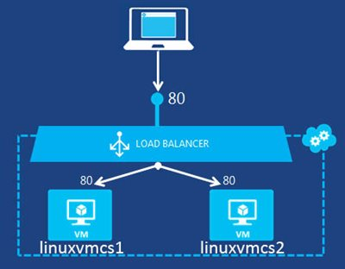](http://social.technet.microsoft.com/wiki/cfs-file.ashx/__key/communityserver-wikis-components-files/00-00-00-00-05/7450.loadbalancing1.jpg)

# Prerequisites

* **​**Microsoft Azure Subscription (MSDN subscribers or [sign up for one month free trial](https://azure.microsoft.com/en-us/free/))
* PuTTY – free SSH or telnet client. [Click here](http://www.putty.org/) for setup

**You will learn**

* How to Create Ubuntu Server
* Deployment Models: Classic
* How to establish connection with Ubuntu Server
* How to Configure Azure Load Balancer of Ubuntu Virtual Machine

# Create Ubuntu Virtual Machine

**Step 1:**Navigate to Azure Portal (http://portal.azure.com/) & sign in with Azure Credentials  
 **Step 2:** Click on New button -> Virtual Machine-> Ubuntu Server 14.04 LTS -> Classic (deployment model)  
Click on "Create" button

[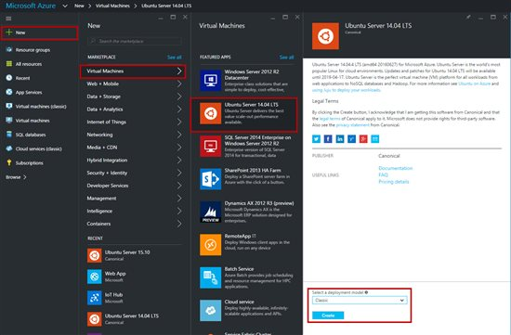](http://social.technet.microsoft.com/wiki/cfs-file.ashx/__key/communityserver-wikis-components-files/00-00-00-00-05/6708.LVMLB01.jpg)

**Step 3:**Enter Host Name, Username & Password or SSH public key  
  
[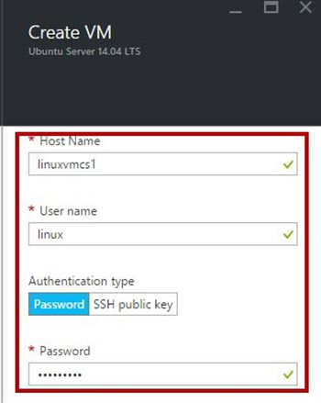](http://social.technet.microsoft.com/wiki/cfs-file.ashx/__key/communityserver-wikis-components-files/00-00-00-00-05/8080.LVMLB02.jpg)

**Step 4:**Choose “Pricing Tier” from the list  
  
[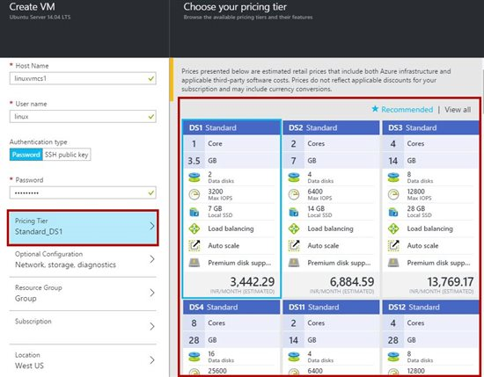](http://social.technet.microsoft.com/wiki/cfs-file.ashx/__key/communityserver-wikis-components-files/00-00-00-00-05/8662.LVMLB03.jpg)

**Step 5:** Optional Configuration - leave with default options.  
  
[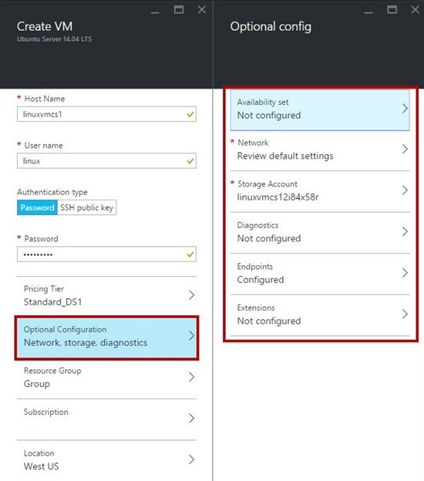](http://social.technet.microsoft.com/wiki/cfs-file.ashx/__key/communityserver-wikis-components-files/00-00-00-00-05/5340.LVMLB04.jpg)

**Step 6:** Resource Group – Create New Resource or use existing group  
  
[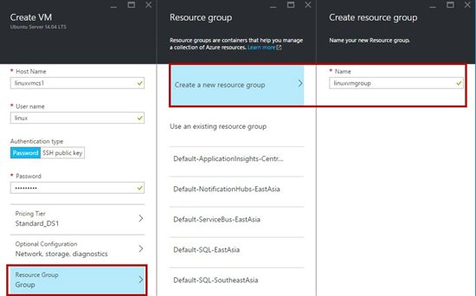](http://social.technet.microsoft.com/wiki/cfs-file.ashx/__key/communityserver-wikis-components-files/00-00-00-00-05/5282.LVMLB05.jpg)

**Step 7:**Subscription – Select subscription if multiple subscription available.

**Step 8:** Location – different locations are available. Select location from the list.

**[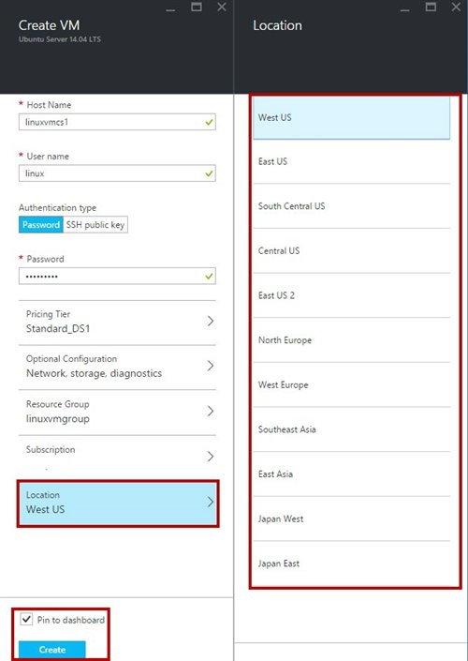](http://social.technet.microsoft.com/wiki/cfs-file.ashx/__key/communityserver-wikis-components-files/00-00-00-00-05/2021.LVMLB06.jpg)**  
  
after all settings click on "Create" button  
  
[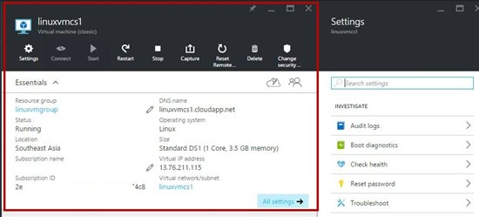](http://social.technet.microsoft.com/wiki/cfs-file.ashx/__key/communityserver-wikis-components-files/00-00-00-00-05/1145.LVMLB07.jpg)  
  
**Step 9:**Now Linux VM is ready but we need to configure LAMP stack inside Linux VM

Download PuTTY Client from

<http://www.putty.org/>

Run PuTTY Client & enter DNS Name or Host Name or IP Address

[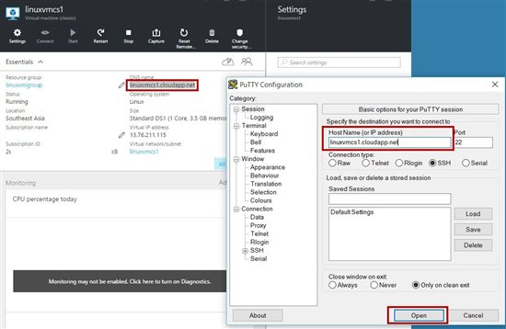](http://social.technet.microsoft.com/wiki/cfs-file.ashx/__key/communityserver-wikis-components-files/00-00-00-00-05/7127.LVMLB08.jpg)

**Step 10:** Enter linux vm username & password

Linux Virtual Machine 1 is running: Ex. Linuxvmcs1   
  
[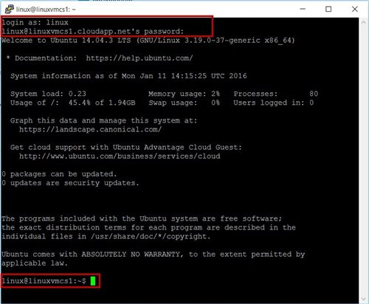](http://social.technet.microsoft.com/wiki/cfs-file.ashx/__key/communityserver-wikis-components-files/00-00-00-00-05/6735.LVMLB09.jpg)

**Step 11:** Change the permission to root

*sudo su*

[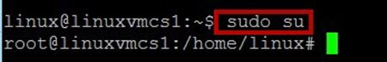](http://social.technet.microsoft.com/wiki/cfs-file.ashx/__key/communityserver-wikis-components-files/00-00-00-00-05/4405.LVMLB10.jpg) **Step 12:** To install LAMP stack inside VM run the following commands

*apt-get install tasksel*

*tasksel*

[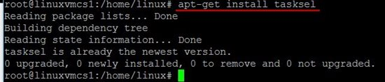](http://social.technet.microsoft.com/wiki/cfs-file.ashx/__key/communityserver-wikis-components-files/00-00-00-00-05/1614.LVMLB11.jpg)[http://social.technet.microsoft.com/wiki/resized-image.ashx/__size/500x0/__key/communityserver-wikis-components-files/00-00-00-00-05/2260.LVMLB12.jpg](http://social.technet.microsoft.com/wiki/cfs-file.ashx/__key/communityserver-wikis-components-files/00-00-00-00-05/2260.LVMLB12.jpg) **Step 13:** Package Configuration windows will run

Select “LAMP Server”.

press TAB & hit ENTER  
  
[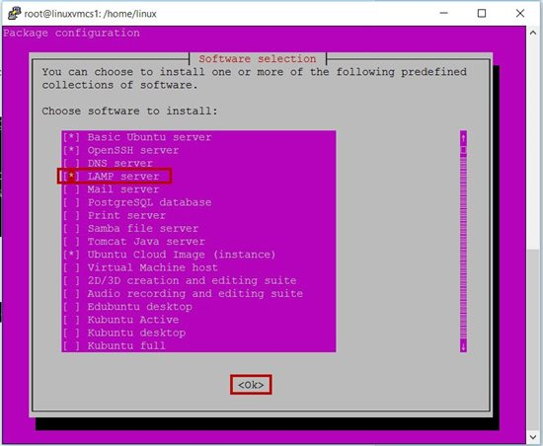](http://social.technet.microsoft.com/wiki/cfs-file.ashx/__key/communityserver-wikis-components-files/00-00-00-00-05/3566.LVMLB13.jpg)

Enter MySQL password during installation.  
  
[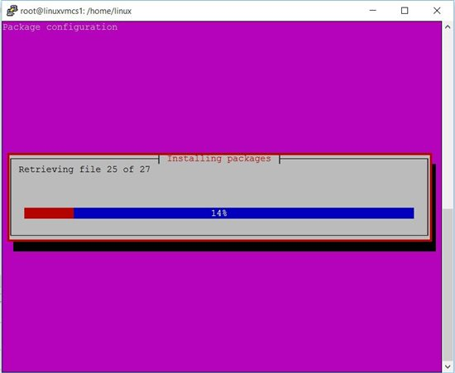](http://social.technet.microsoft.com/wiki/cfs-file.ashx/__key/communityserver-wikis-components-files/00-00-00-00-05/4786.LVMLB14.jpg)

**Step 14:** Navigate to main directory or folder

*cd{space}/*

[http://social.technet.microsoft.com/wiki/resized-image.ashx/__size/500x0/__key/communityserver-wikis-components-files/00-00-00-00-05/2744.LVMLB15.jpg](http://social.technet.microsoft.com/wiki/cfs-file.ashx/__key/communityserver-wikis-components-files/00-00-00-00-05/2744.LVMLB15.jpg) **Step 15:** Again navigate to LAMP stack installation directory by running following commands

*cd{space}var/www/html*

[http://social.technet.microsoft.com/wiki/resized-image.ashx/__size/500x0/__key/communityserver-wikis-components-files/00-00-00-00-05/5875.LVMLB16.jpg](http://social.technet.microsoft.com/wiki/cfs-file.ashx/__key/communityserver-wikis-components-files/00-00-00-00-05/5875.LVMLB16.jpg)  
  
Note: apache default page available inside html folder but if VM is Ubuntu 12.04 html directory is not available.

Linux 12.04 LTS - cd var/www

Linux 14.04 LTS - cd var/www/html

**Step 16:** Start the nano editor type following command

*nano default.php  
  
[http://social.technet.microsoft.com/wiki/resized-image.ashx/__size/500x0/__key/communityserver-wikis-components-files/00-00-00-00-05/2260.LVMLB17.jpg](http://social.technet.microsoft.com/wiki/cfs-file.ashx/__key/communityserver-wikis-components-files/00-00-00-00-05/2260.LVMLB17.jpg)  
  
[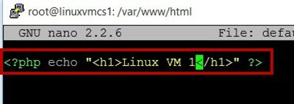](http://social.technet.microsoft.com/wiki/cfs-file.ashx/__key/communityserver-wikis-components-files/00-00-00-00-05/7610.LVMLB18.jpg)*

<?**php** echo "<h1>Linux VM 1</**h1**>" ?>

"Ctrl + x" then "y" and press "Enter"

Now close or exit the connection of first Linux VM.

**Step 17:** Create another Linux VM

New -> Virtual Machine -> Ubuntu Server 14.04 LTS -> Classic (deployment model)

[](http://social.technet.microsoft.com/wiki/cfs-file.ashx/__key/communityserver-wikis-components-files/00-00-00-00-05/0211.LVMLB19.jpg) **Step 18:**Enter Second VM Host Name, Username & Password or SSH public key  
  
[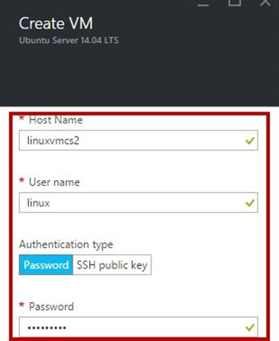](http://social.technet.microsoft.com/wiki/cfs-file.ashx/__key/communityserver-wikis-components-files/00-00-00-00-05/7288.LVMLB20.jpg)

**Step 19:**Select “Optional Configuration” -> “Network” -> “Domain Name” -> Choose an existing domain name option with existing cloud domain name.

Choose first vm domain name ex. linuxvmcs1.cloudapp.net  
  
[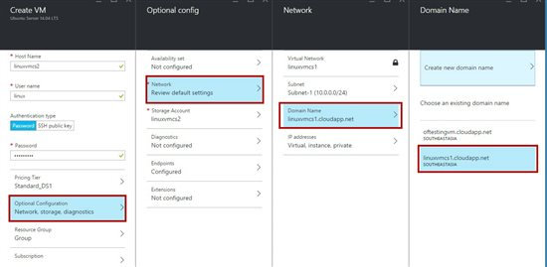](http://social.technet.microsoft.com/wiki/cfs-file.ashx/__key/communityserver-wikis-components-files/00-00-00-00-05/0131.LVMLB21.jpg)

**Step 20:** After selecting same dns name automatic all values will set such as “Resource Group”, “Subscription”, “Location”  
  
[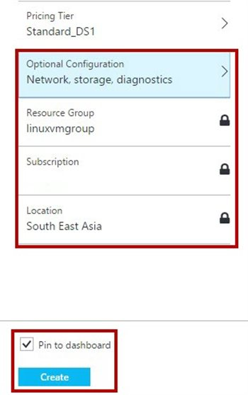](http://social.technet.microsoft.com/wiki/cfs-file.ashx/__key/communityserver-wikis-components-files/00-00-00-00-05/3058.LVMLB22.jpg)  
  
[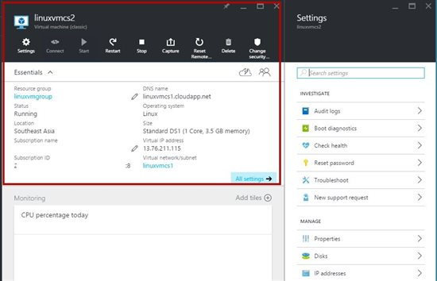](http://social.technet.microsoft.com/wiki/cfs-file.ashx/__key/communityserver-wikis-components-files/00-00-00-00-05/8463.LVMLB23.jpg)

In Settings blade select “Properties” -> SSH value

For second VM DNS Name will be same but port number is different

Ex. 1st VM – linuxvmcs1.cloudapp.net:22

      2nd VM –linuxvmcs1.cloudapp.net:63784  
  
[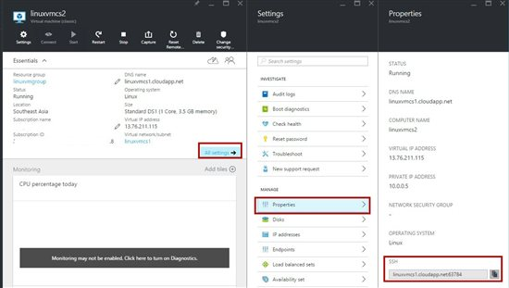](http://social.technet.microsoft.com/wiki/cfs-file.ashx/__key/communityserver-wikis-components-files/00-00-00-00-05/3660.LVMLB24.jpg)

**Step 21:** Again run the PuTTY SSH Client & Enter values according to second VM  
  
[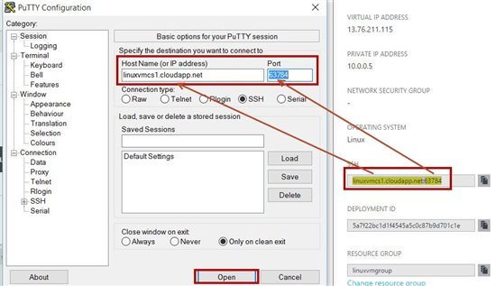](http://social.technet.microsoft.com/wiki/cfs-file.ashx/__key/communityserver-wikis-components-files/00-00-00-00-05/7651.LVMLB25.jpg)  
  
[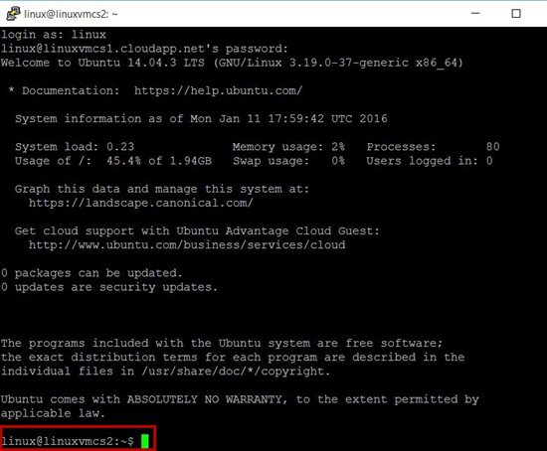](http://social.technet.microsoft.com/wiki/cfs-file.ashx/__key/communityserver-wikis-components-files/00-00-00-00-05/0844.LVMLB26.jpg)

DNS name is same but virtual machine is different ex. linuxvmcs2

**Step 22:** Change the permission to root

*sudo su*

[http://social.technet.microsoft.com/wiki/resized-image.ashx/__size/400x0/__key/communityserver-wikis-components-files/00-00-00-00-05/3157.LVMLB27.jpg](http://social.technet.microsoft.com/wiki/cfs-file.ashx/__key/communityserver-wikis-components-files/00-00-00-00-05/3157.LVMLB27.jpg) **Step 23:** To install LAMP stack inside VM run the following commands

*apt-get install tasksel*

*tasksel*

[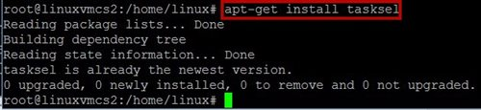](http://social.technet.microsoft.com/wiki/cfs-file.ashx/__key/communityserver-wikis-components-files/00-00-00-00-05/5153.LVMLB28.jpg)[http://social.technet.microsoft.com/wiki/resized-image.ashx/__size/450x0/__key/communityserver-wikis-components-files/00-00-00-00-05/0511.LVMLB29.jpg](http://social.technet.microsoft.com/wiki/cfs-file.ashx/__key/communityserver-wikis-components-files/00-00-00-00-05/0511.LVMLB29.jpg) **Step 24:**Package Configuration windows will run

Select “LAMP Server”. Press TAB & hit ENTER  
  
[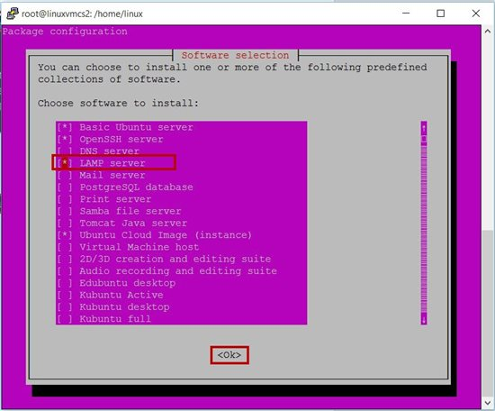](http://social.technet.microsoft.com/wiki/cfs-file.ashx/__key/communityserver-wikis-components-files/00-00-00-00-05/0361.LVMLB30.jpg)

Enter MySQL password during installation.  
  
[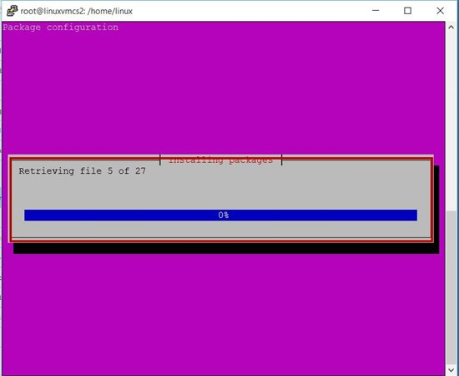](http://social.technet.microsoft.com/wiki/cfs-file.ashx/__key/communityserver-wikis-components-files/00-00-00-00-05/0878.LVMLB31.jpg)

**Step 25:** Navigate to main directory or folder

*cd{space}/*

[http://social.technet.microsoft.com/wiki/resized-image.ashx/__size/450x0/__key/communityserver-wikis-components-files/00-00-00-00-05/1781.LVMLB15.jpg](http://social.technet.microsoft.com/wiki/cfs-file.ashx/__key/communityserver-wikis-components-files/00-00-00-00-05/1781.LVMLB15.jpg) **Step 26:** Again navigate to LAMP stack installation directory by running following commands

*cd{space}var/www/html*

[http://social.technet.microsoft.com/wiki/resized-image.ashx/__size/400x0/__key/communityserver-wikis-components-files/00-00-00-00-05/3835.LVMLB33.jpg](http://social.technet.microsoft.com/wiki/cfs-file.ashx/__key/communityserver-wikis-components-files/00-00-00-00-05/3835.LVMLB33.jpg)  
  
Note: apache default page available inside html folder but if VM is Ubuntu 12.04 html directory is not available.

Linux 12.04 LTS - cd var/www

Linux 14.04 LTS - cd var/www/html

**Step 27:**Start the nano editor type following command

*nano default.php  
  
[http://social.technet.microsoft.com/wiki/resized-image.ashx/__size/450x0/__key/communityserver-wikis-components-files/00-00-00-00-05/2477.LVMLB34.jpg](http://social.technet.microsoft.com/wiki/cfs-file.ashx/__key/communityserver-wikis-components-files/00-00-00-00-05/2477.LVMLB34.jpg)  
  
[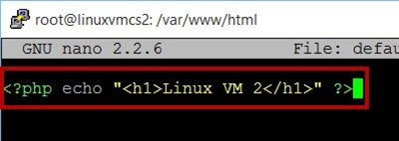](http://social.technet.microsoft.com/wiki/cfs-file.ashx/__key/communityserver-wikis-components-files/00-00-00-00-05/4405.LVMLB35.jpg)*

<?**php** echo "<h1>Linux VM 2</**h1**>" ?>

"Ctrl + x" then "y" and press "Enter"

Close or Exit second VM connection

# Configure Load Balancer sets

**​Step 28:**Select “Load balanced sets” option of 2nd VM  
  
[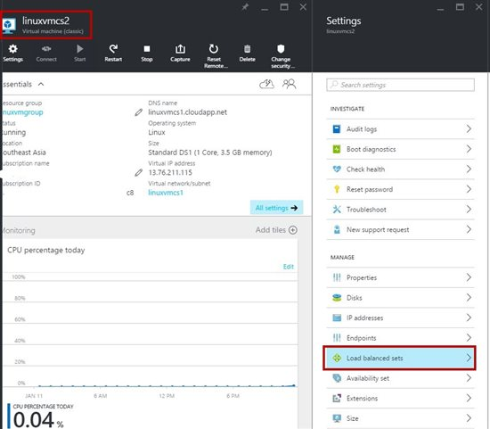](http://social.technet.microsoft.com/wiki/cfs-file.ashx/__key/communityserver-wikis-components-files/00-00-00-00-05/4137.LVMLB36.jpg)

**Step 29:**Load balanced sets blade will open.

Click on “Join” option -> Load balanced set -> Create a load balanced set -> enter name, port, etc.  
  
[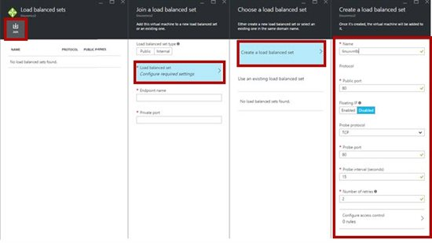](http://social.technet.microsoft.com/wiki/cfs-file.ashx/__key/communityserver-wikis-components-files/00-00-00-00-05/4331.LVMLB37.jpg)

When all value set of load balanced set  
  
[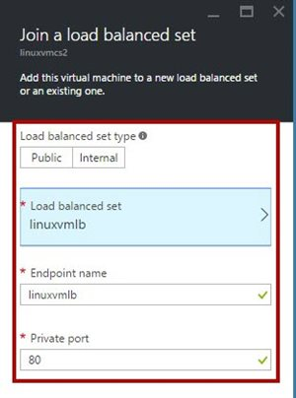](http://social.technet.microsoft.com/wiki/cfs-file.ashx/__key/communityserver-wikis-components-files/00-00-00-00-05/0825.LVMLB38.jpg)

After few second load balancer will generate  
  
[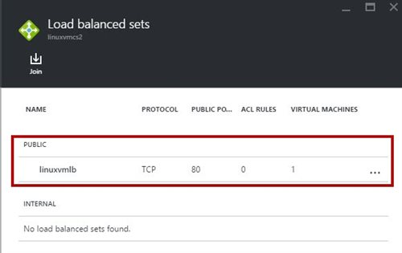](http://social.technet.microsoft.com/wiki/cfs-file.ashx/__key/communityserver-wikis-components-files/00-00-00-00-05/4010.LVMLB39.jpg)

**Step 30:** Now select 1st VM

Settings blade -> “Load balanced sets” -> “Join” option  
  
[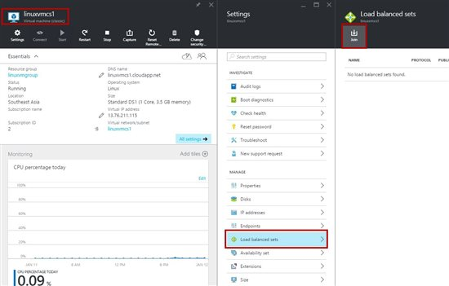](http://social.technet.microsoft.com/wiki/cfs-file.ashx/__key/communityserver-wikis-components-files/00-00-00-00-05/7220.LVMLB40.jpg)

**Step 31:** First select Load balanced set option & then load balanced set blade will open.

Select “Use existing load balanced set” option ex. linuxvmlb  
  
[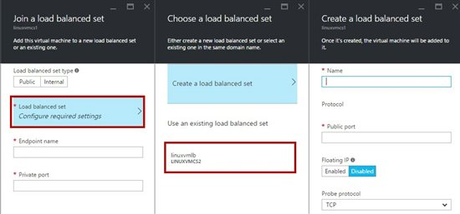](http://social.technet.microsoft.com/wiki/cfs-file.ashx/__key/communityserver-wikis-components-files/00-00-00-00-05/6787.LVMLB41.jpg)

Automatic all values will set   
  
[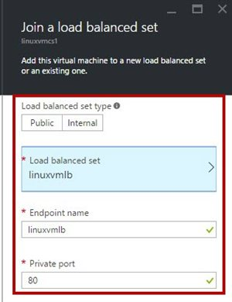](http://social.technet.microsoft.com/wiki/cfs-file.ashx/__key/communityserver-wikis-components-files/00-00-00-00-05/4237.LVMLB42.jpg)

After load balanced set to 2 VM  
  
[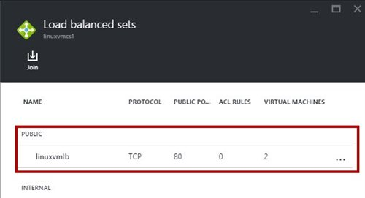](http://social.technet.microsoft.com/wiki/cfs-file.ashx/__key/communityserver-wikis-components-files/00-00-00-00-05/8585.LVMLB43.jpg)  
  
[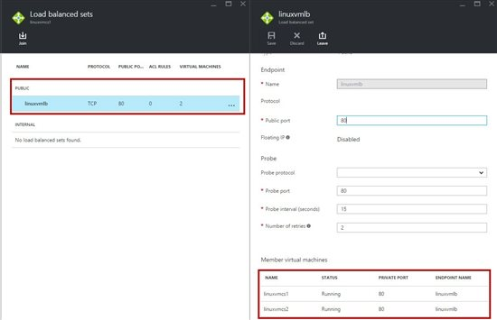](http://social.technet.microsoft.com/wiki/cfs-file.ashx/__key/communityserver-wikis-components-files/00-00-00-00-05/4846.LVMLB44.jpg)

Now open the browser & type dns name

[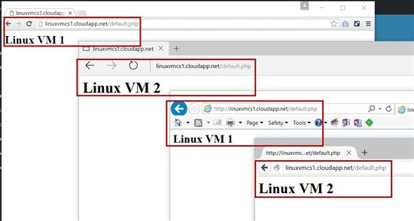](http://social.technet.microsoft.com/wiki/cfs-file.ashx/__key/communityserver-wikis-components-files/00-00-00-00-05/6403.LVMLB45.jpg)  
  
  
Congratulations you have successfully configured Load Balancing workloads between two Linux Virtual Machine!